**Team Members:** Thomas Bock, Ammar Ahmed, Tan Hua, Jan Michael Golez

.

**Group Meeting Minutes:**

* Integration between software/Machine Vision:
* Construction of Laser Shroud
* Extension/Shortening of wires
* Mount the control boards
* Mount the Camera
* Plans for Laser Housing will be halted,instead the main focus will be directed towards integrating of all four individual parts
* A suggestion of replacement towards the microcontroller will be in discussion.
* A new driver for the laser diode will be in discussion to understand and promote compatibility
* Plans for assisting on the software once both mechanics and laser are done.
* Discuss group meetings for possible future problems arising with this project.



1st working Prototype Draft

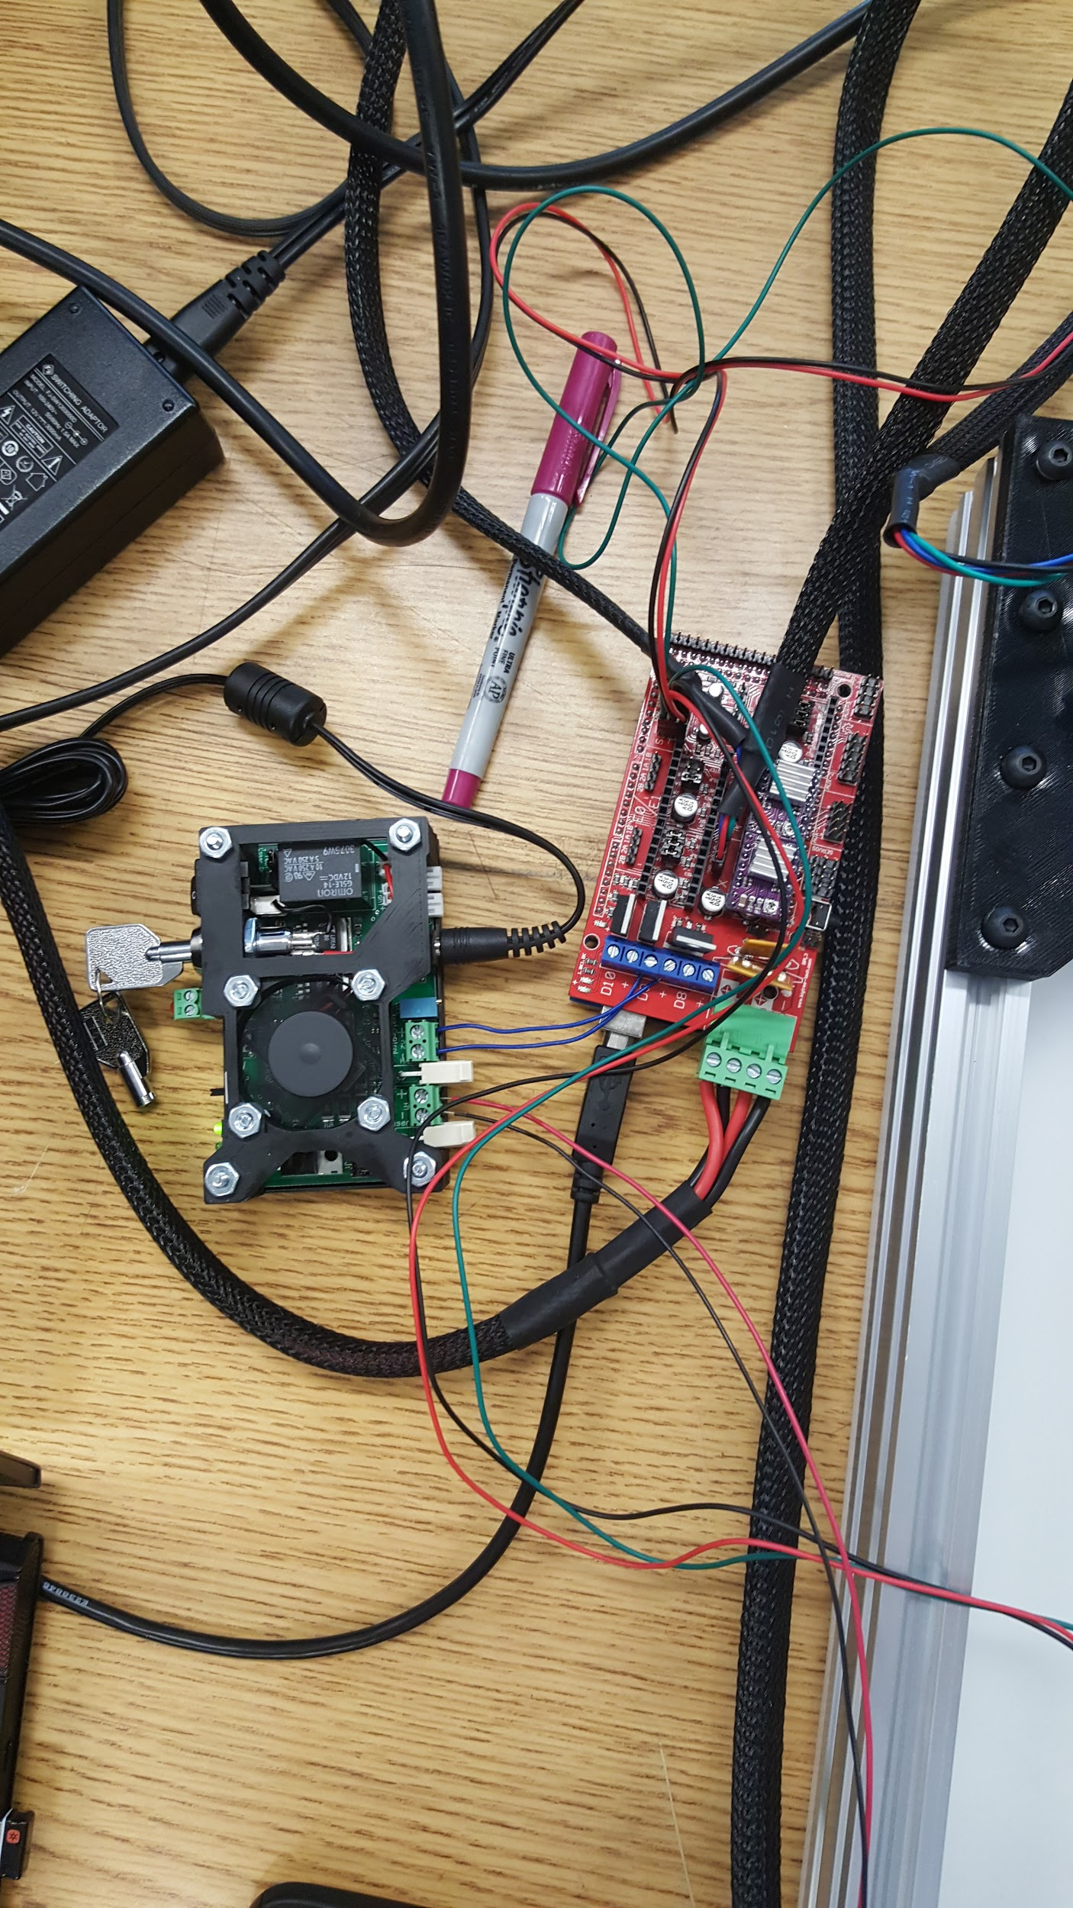

2.5 Amp Adjustable Safety Compliant Laser Diode Driver ;Ramps Board

**Summary of Team Tasks Assigned:**

1. Mechanics
2. Integration
3. Laser Housing created
4. Laser Diode
   1. PWM Laser Diode for control
   2. Prototype Laser Driver: vary voltage to reproduce constant current source on the laser driver
   3. Integrate the Laser with the mechanics and software to view the combine process.
5. Software
6. Complete process from design to execution
7. Computer Vision
   1. Work on algorithm for edge detection( needed for dimension detection)

**Summary of Team Accomplishments:**

1. Mechanics
2. Laser housing created
3. Mechanics assembled
4. Parts completed 3d printed
5. Testing Mechanics - No binding with parts, should be good
6. Laser Diode
7. PWM on the laser diode to allow control on the laser
8. Enhancing Prototype Laser Driver to ensure reproduction of the constant current source on the Laser Driver
9. 1st integration of the laser with mechanics, software, and laser.
10. Software
11. Both motors work and follow G-code instruction
12. G-code generator from inkscape for cutting and rasterizing
13. Integration with mechanics and laser works properly
14. Computer Vision
15. An algorithm was found for filling circular objects but still working on the drawing box around the detected object.

**Tasks Assigned for Next reporting period:**

1. Mechanics
   1. Design and Build Camera mount
2. Laser Diode
3. More testing on the Laser Diode
4. Propose another solution for outputting the right current towards the laser diode based on the prototype driver
5. Refurbishment/Improvement of the CNC Laser.
6. Software
7. Complete process from design to execution
8. Integrating with machine vision
9. Computer Vision
   1. Resolve the issue by finding the algorithm for filling the gaps or drawing a box around the detected object

**Issues:**

1. Mechanic with Software: reverse direction of the core x-y
2. Laser with Software: TTL integration with the board was not working; Laser Pinout was communicating with the Laser Diode( it wasn't turning on)
3. Camera Vision with Software: the camera couldn't detect dimensions and be outputted towards an Excel file
4. Although 1st integration was successful, we need to be able to ensure all four parts communicate. This will require thorough analysis and lots of debugging.
5. Testing M

**Individual Summary (cont.)**

**Name:** Thomas Bock

**Tasks Assigned for this reporting period:**

1. Testing Core X-Y with Laser

**Accomplishments this reporting period:**

1. Integration of software working
2. Integration of Laser working
3. Testing complete with a pen and the laser

**Issues:**

1. At first, TTL communication with laser driver board was not working. This was remedied by using a new driver board, and modifying the firmware on the RAMPS board to output the TTL communication through a different pin
2. The Laser mount works at the moment, but will need a redesign to mount a cooling fan.
3. At first, dimensions were off on how much the laser head moved compared to how much it was supposed to move. This was remedied by modifying some settings in the firmware, namely the “Steps per MM” setting from 80 to 320.

**Tasks Assigned for Next reporting period:**

1. Design and Assemble Camera mounting

**Individual Summary (cont.)**

**Name:** Jan Michael Golez

**Tasks Assigned for this reporting period:**

1. PWM the Laser Diode for control
2. Prototype Laser Diode: Vary voltage to reproduce constant current source on the laser driver.
3. Integrate the Laser with the mechanics and software to view the combined process.

**Accomplishments this reporting period:**

1. Laser Diode was able to PWM the signal allowing a controller to turn the laser on and off .
2. Prototype Laser Diode, functions, however to get desired output of the as the original driver variations were added
3. Integration of both mechanics, software, and laser.

**Issues:**

1. Continued integration along with the mechanics and software are a success, however need better understand on the microcontroller
2. Power distribution, will it be distributed equally?

**Tasks Assigned for Next reporting period:**

1. Continue integration of the mechanic and software along with the laser to correct for unnecessary problems
2. Start understanding the pint out on the base microcontroller on the CNC LASER to help integrate the laser with the mechanics and software.
3. Learn to use the COMpliant Laser Diode Driver for future enhancements on the CNC LASER.

0

**Individual Summary (cont.)**

**Name:** Tan Hua

**Tasks Assigned for this reporting period:**

1. Complete process from design to execution

**Accomplishments this reporting period:**

1. Both motors work and follow G-code instruction
2. G-code generator from inkscape for cutting and rasterizing
3. Integration with mechanics works properly

**Issues:**

1. Wrong directions when integrating with mechanics
2. Laser was not turned on when hooking up to the boards
3. G-code did not home before and after executing

**Tasks Assigned for Next reporting period:**

1. Complete process from design to execution
2. Integrating with machine vision

**Individual Summary (cont.)**

**Name:** Ammar Ahmed

**Tasks Assigned for this reporting period:**

1. Continue working on the algorithm for filling gaps.
2. Figure out how to measure dimensions on image in pixels so that it can be converted later on to actual dimensions in cm.

**Accomplishments this reporting period:**

1. The algorithm issue was solved. Gaps are filled based on morphological transform (Dilate method applied).
2. Algorithm was written to find dimensions of an object in pixel, Figure 4.1 below shows a picture of the phone taken by the camera and the dimensions were found in pixel.

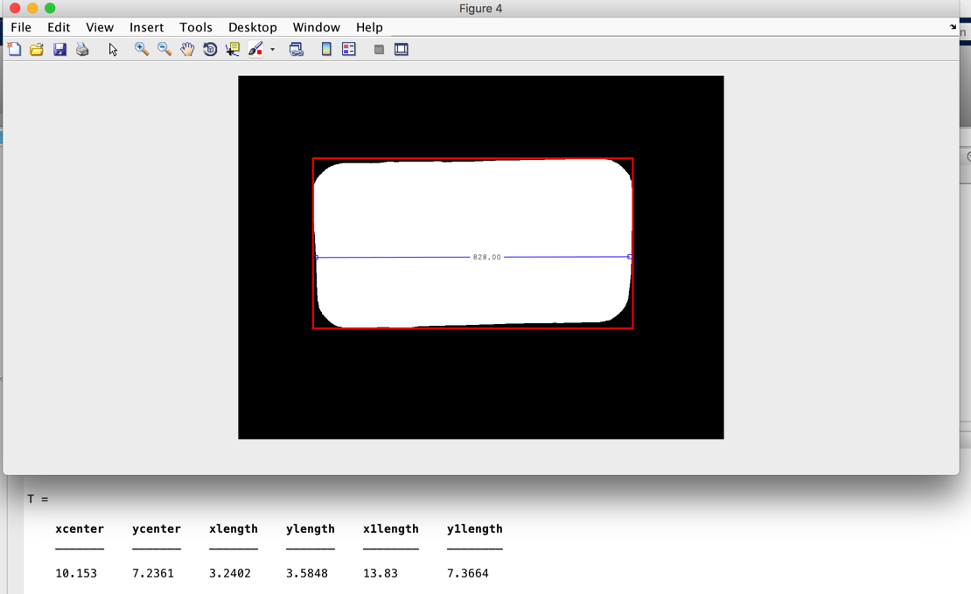

Figure 4.1: shows a picture of the detected phone captured by the camera in binary

**Issues:**

1. No issues so far.

**Tasks Assigned for Next reporting period:**

1. Calibrating the camera to get dimensions in real world unit.